# SHOPNEST CAPSTONE PROJECT

Question 1)

Identify the rating distribution in the Shop_Nest dataset, showcasing ratings categorized as Excellent, Very Good, Good, Bad, Very Bad, along with corresponding orders.

Visualization-

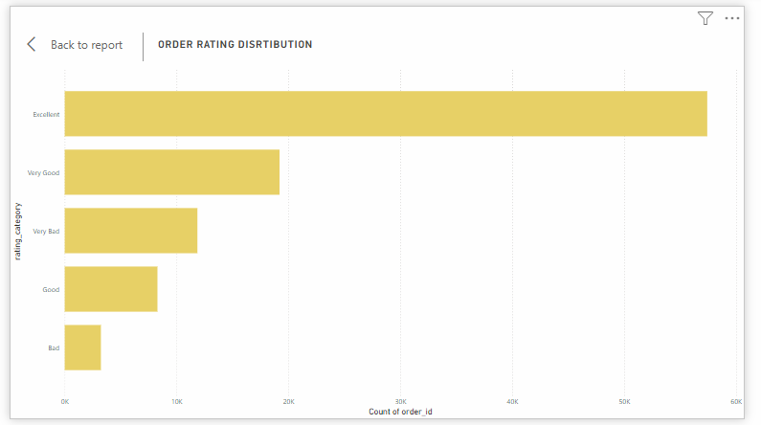

Explanation-

This bar chart displays the distribution of customer ratings for the Shop_Nest. The ratings are categorized into five groups: Excellent, Very Good, Good, Bad, and Very Bad.

-The Majority of customers rate their shopping experience as ‘Excellent’ reflecting overall satisfaction.

-Few customers rate their experience as ‘Bad’ or ‘Very Bad’ indicating minimal dissatisfaction.

-The high proportion of positive ratings suggests that customers are generally happy with their experience, though the negative feedback should still be addressed by Shop_Nest.

Question 2)

What are the top 10 and bottom 18 most popular product categories in the Shop_Nest dataset? Please list them based on the number of orders.

Visualization-

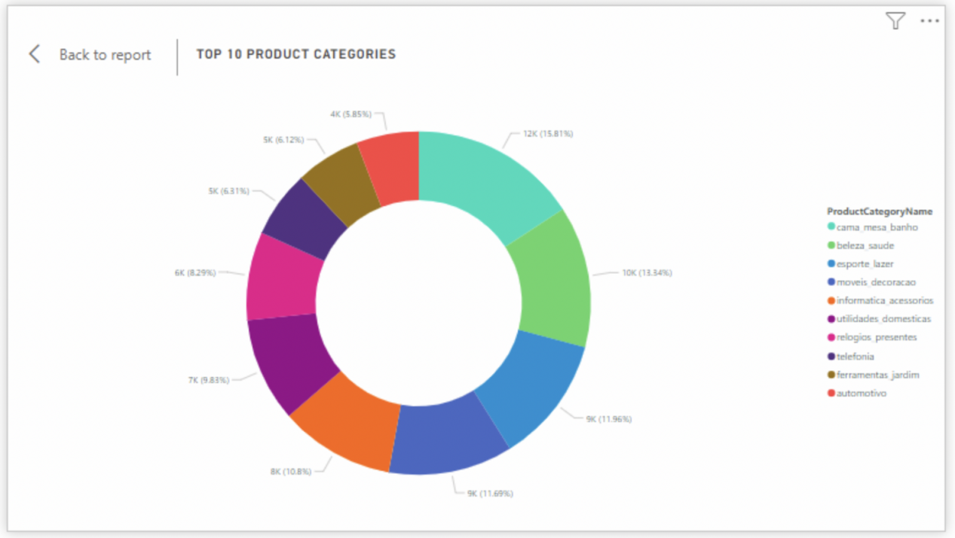

Top 10

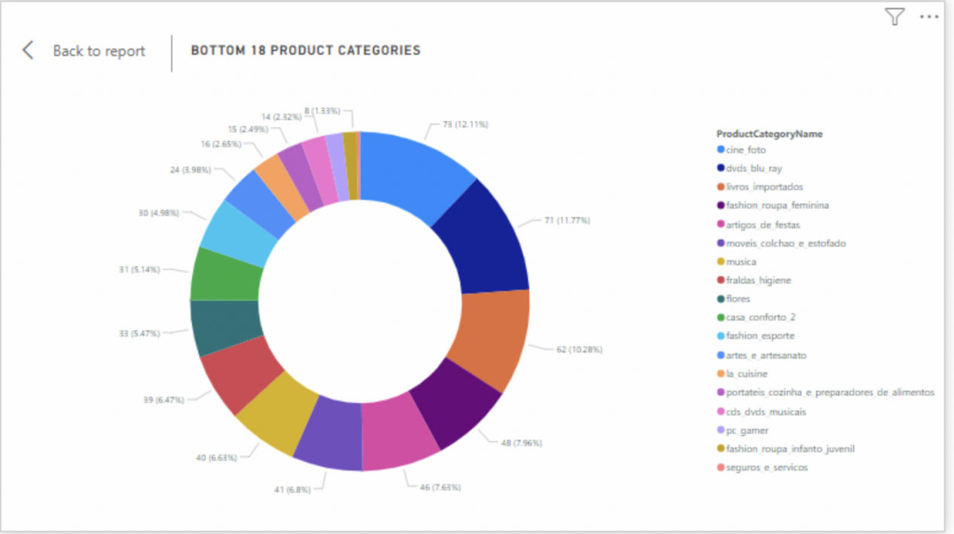

Bottom 18

Explanation-

-Th donut chart shows the **top 10** product categories based on the number of orders. Each category is represented by a percentage of total orders, with categories such as "beleza_saude" (Beauty and Health) and "esporte_lazer" (Sports and Leisure) leading the chart.

-"cama_mesa_banho" (Bed, Bath, and Table) and "beleza_saude" (Beauty and Health) are the most popular categories, accounting for a significant portion of total orders.

-These popular categories likely generate the most revenue for Shop_Nest and could benefit from continued marketing focus.

-The donut chart displays the **bottom 18** product categories in terms of orders. These categories have the lowest share of total orders.

-Categories such as "cine_foto" (Cine/Photo) and "dvds_blu_ray" (DVDs/Blu-Ray) are among the least ordered, suggesting that they may not be popular with Shop_Nest customers.

-These categories may require marketing initiatives to increase sales or could be phased out if demand continues to remain low.

Question 3)

List the total number of active sellers by yearly and monthly.

Visualization-

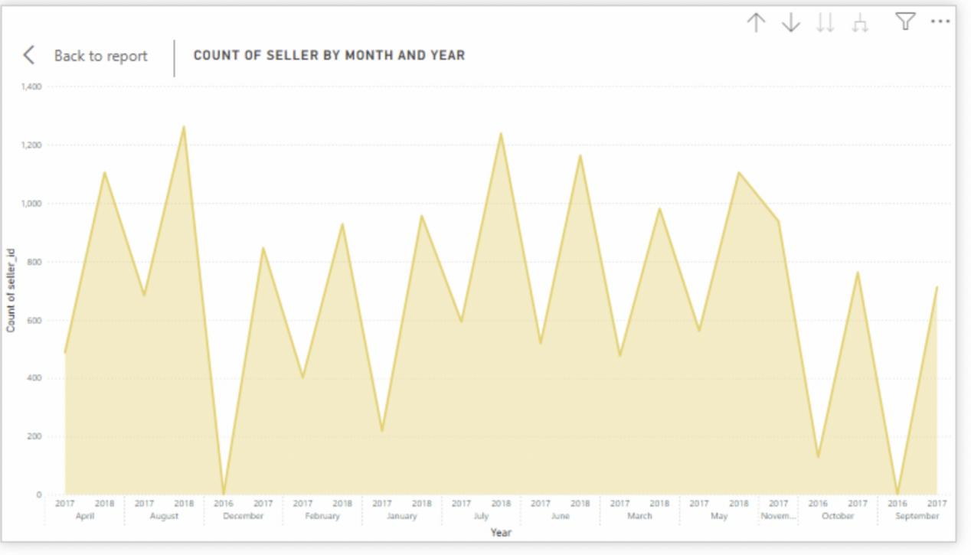

Explanation-

-This line chart tracks the number of active sellers by month and year. The chart provides insight into seller activity trends over time.

-There is an overall consistent growth number of active sellers with occasional spikes, suggesting periods of higher seller on-boarding or engagement.

Question 4)

Which Payment methods are most commonly used by Shop_Nest customers.

Visualization-

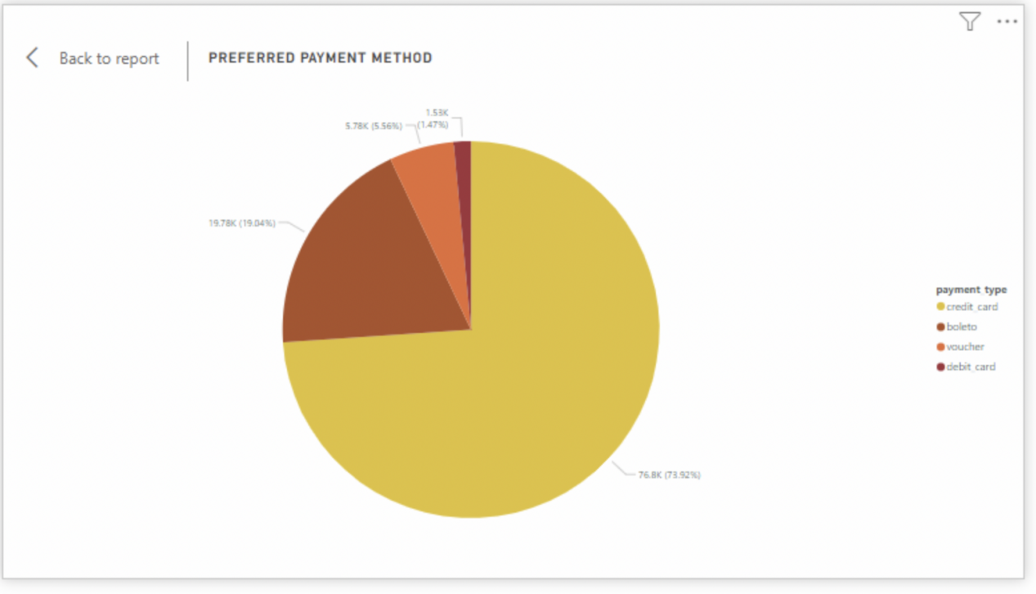

Explanation-

-This pie chart shows the most commonly used payment methods by Shop_Nest customers. The four options include credit cards, debit cards, vouchers, and boleto (Brazilian payment method).

-Credit cards are the most popular payment method, accounting for **73.26%** of payments, followed by debit cards at **19.78%**.

-The usage of vouchers and boleto is much lower, indicating that customers prefer direct digital payments.

-Shop_Nest should continue to optimize their payment process for credit card transactions, as they dominate customer preference.

Question 5)

Identify the product category, wise profit margin using the formula.

Visualization-

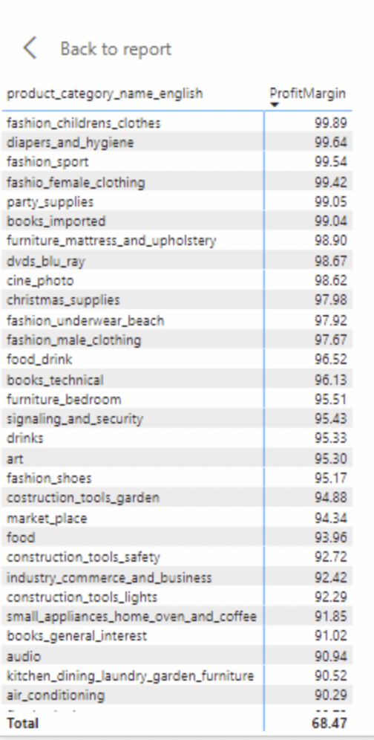

Explanation-

-This table shows the profit margins for each product category, calculated using the formula: `(Payment value - Price + Freight value) / Payment value * 100`.  
-Product categories such as "fashion_childrens_clothes" and "diapers_and_hygiene" have high profit margins, while "drinks" have a relatively low margin.  
-Focusing on the high-margin categories could help increase profitability, while cost optimizations might be needed for lower-margin categories.

Question 6)

Determine the monthly payments made by customers using credit cards.

Visualization-

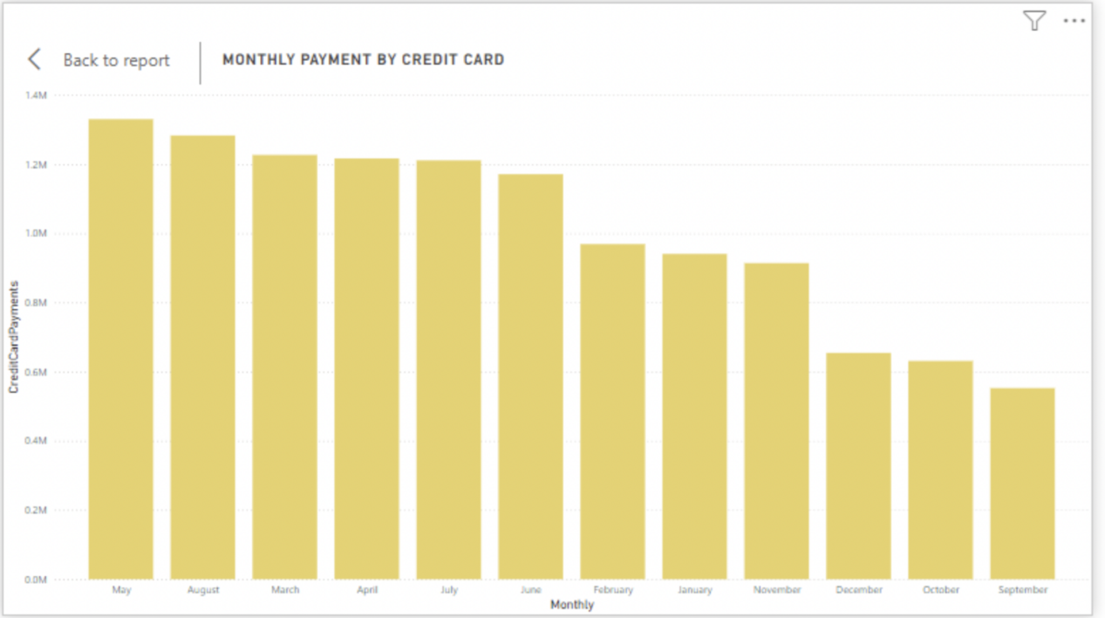

Explanation-

-This bar chart tracks monthly payments made using credit cards. The visual shows payment trends for each month.

-There is a consistent volume of credit card payments across the months, with slight increases during certain periods, potentially during holiday seasons or promotions.

-The stable trend suggests that credit card payments are a reliable method for Shop_Nest customers.

Question 7)

Identify sellers categorized by city, excluding cities starting with the letters S and B.

Visualization-

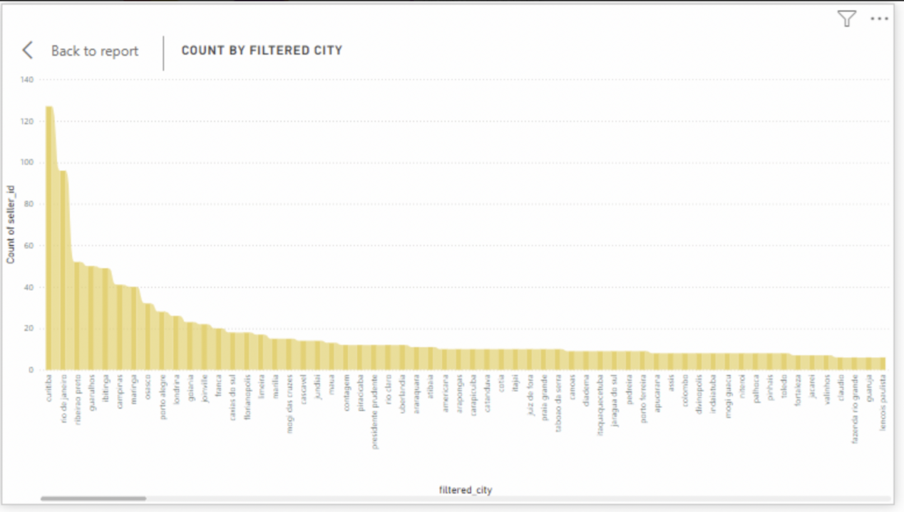

Explanation-

-This bar chart shows the number of sellers based on their city location, excluding cities starting with the letters "S" and "B." The cities are ranked by seller count.

-Some cities, like "curitiba" and "recife," have a higher concentration of sellers compared to other locations.

-Knowing which cities have the most active sellers can help Shop_Nest focus its marketing or seller engagement efforts in those regions.

Question 8)

Create a dynamic visual that compares the number of delayed orders to the number of orders received earlier for each month. Utilize the drill through the cross-report feature to provide a detailed analysis of late and on-time deliveries.

Visualization-

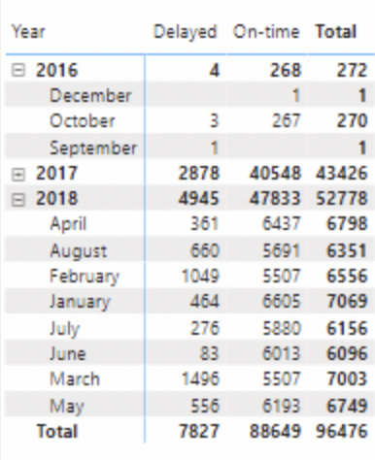

Explanation-

-Here I have used the drill up/down to create a dynamic view.

-This table shows a comparison between delayed and on-time orders for different months and years.  
-The table highlights the number of delayed and on-time orders for each year, with 2017 showing a relatively high number of on-time deliveries compared to delays.  
-The ability to track this data over time helps in identifying and addressing logistics issues, particularly in months with more delays.